Arrangement of materials
Preliminary pages
Should be in the following order:
        - Title page
        - Abstract
        - Declaration/ Statement of Authorship
        - Acknowledgements
        - Dedications (Optional)
        - Table of Contents
        - List of Figures
        - List of Tables
        - List of Abbreviations
        - Preface (Optional)
Main text: Chapters may be;
Introduction, Literature Review, Methodology and Techniques Applied, Results, Discussion and Conclusions.
End Matter
Order is Appendices (Optional), Glossary (Optional), List of References/ Bibliography
Table of contents

Chapter 1 Introduction
1.1. Background
1.2. Problem Identification
1.3. Significance of Research
1.4. Objectives of the Study
1.5. Chapter Framework

Chapter 2 Literature Review

Chapter 3 Theory and Methodology
3.1 Research Design
3.2. Data Collection Method
3.3 Structure of the Questionnaire
3.4 Preliminary Data Analysis
3.4.1. Descriptive Analysis
3.4.2. Analyzing Demographic Data

Chapter 4 Results
4.1 Inferential data analysis (using R)

Chapter 5 Discussion and Conclusion

CHAPTER 03
Preliminary Analysis of CKD patients

The purpose of this chapter is to present the results of some statistical approach and discuss them very briefly. A careful and critical analysis of a data set is an important step in the course of a statistical analysis. The final conclusions cannot be more reliable than the data set they rely on. This chapter deals with the case of given data sets, revealing as much as possible about the structure of the data set, its limitations and peculiarities, is a good starting point for advanced statistical analysis and modeling. Therefore, preliminary data analysis has conducted using simple graphical devices and various measures of ‘location’, ‘spread’ and ‘skewness’ of the data set are introduced.

5.1 Descriptive Statistics

- Composition of Gender
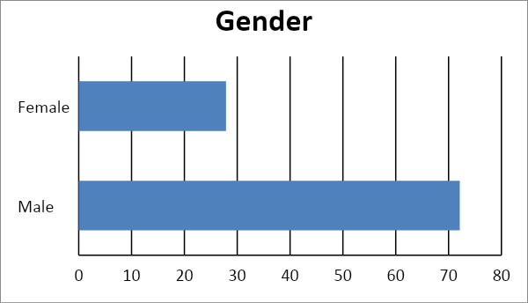
Figure 5.11 Composition of Gender
There are 72.12 percent male patients’ records in the renal registry of Sri Lanka where female patients are 27.88 percent. It shows the number of male patients is higher than female patients where female patients represent approximately one third of the population.
- Composition of Age in years
Table 5.11 Composition of age in years
Table 5.11 Composition of age in years
Age in years | Value(%)
Mean  Median  standard deviation | 47.83  48.00  13.67

The above table shows the mean age of a patient is approximately 48 years; the patients are likely to be young adults. The standard deviation is 13.67. These measurements show that the population caused by renal disease is young adults, representing the most productive years of their lives.

